456/1
  - Given that 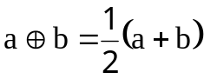 and 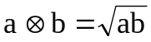.Calculate 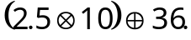
  - Solve the simultaneous equation 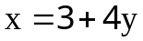
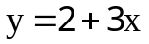
  - Solve the inequality; 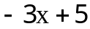<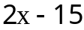 and represent the solution set on a number line.
  - Solve the equation; 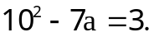
  - Without using tables or calculators find the value of;
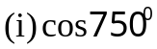
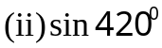
  - Find the image of 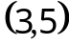under an enlargement about centre 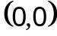 by scale factor 2 followed by a reflection in the y- axis.
  - Given that 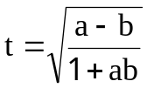, make b the subject of the formula.
  - Find the equation of the perpendicular bisector of line where 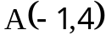and 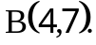
  - In the figure below is a square ABCD inscribed in a circle. If the radius of the circle is 6cm, calculate the area of the shaded.



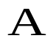

  - A bag contains 5 red and 4 black beads. Two beads are taken out of it. What is the probability that the first is red and second black;
    - if the first bead is replaced .
    - if the first bead is not replaced.

Section B (60 marks)
11. Shown below are marks scored by 60 students in a math test.
45 | 80 | 67 | 75 | 56 | 45 | 30 | 25 | 40 | 50
40 | 62 | 90 | 19 | 45 | 60 | 52 | 81 | 55 | 80
69 | 43 | 20 | 31 | 21 | 50 | 54 | 31 | 30 | 40
49 | 40 | 32 | 70 | 25 | 39 | 40 | 72 | 50 | 49
47 | 39 | 60 | 53 | 45 | 71 | 89 | 47 | 56 | 82
31 | 30 | 56 | 73 | 60 | 69 | 51 | 41 | 66 | 70
- Construct a grouped frequency table having class intervals 10 marks, beginning with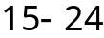 class group.
- Using your grouped frequency table to calculate the mean mark of the candidates.
- Represent the above results on a histogram.
- Use the histogram to estimate the mode.

  - Using a ruler and a pair of compasses and a pencil only;
- Construct a triangle PQR in which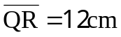, 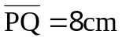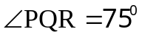.
- From P construct a perpendicular to 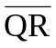 to meet at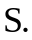
- Construct the bisector of 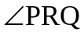to meet at 
- Measure and write down the length of 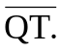

  - ABCD is a parallelogram with 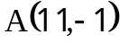,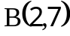and 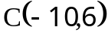.
    - Find the coordinates of D
    - Prove that ABCD is rhombus.
    - Show that the diagonals bisect each other at right angles.

  - 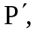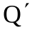and 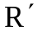 are the images of 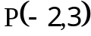,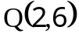 and 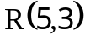respectively under an enlargement of scale factor 2 , centre . Show that the area of triangle 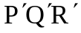 to the area of triangle is 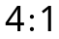

  - Draw a graph of 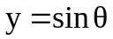for 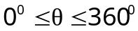
  - Use the graph to read off 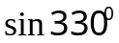
  - Find the sine whose value is 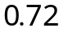

- (a)It is given that y varies partly as x and partly inversely as the square of x. It is also given that 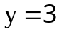when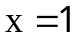 and that 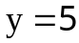when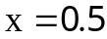 . Find y when 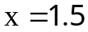
(b)It takes 8 days for 9 men to weed a field of maize. How long would
it take 6 men to weed the same size of field if the work at the same
rate?

- Joanita intends to invite six friends to her home. She wants to give each of them a samosa or a chapatti and have at least one of the items for herself. A samosa costs shs. 500 and a chapatti costs shs. 1000 and she has shs. 10,000 altogether. The number of the chapattis must be at least half the number of samosas.
- Form inequalities relating the number of samosas and chapatti Joanita can buy.
- Graph the inequalities in (i) above as a region.
- Mark lattice points showing possible solutions.
- What is the greatest number of samosas that she can buy?
- What is the greatest number of chapattis that she can buy?
- Which solutions use up all the available money?
- Which solution do you think is the best?

